CHAPTER TWO

LITERATURE REVIEW AND REVIEW OF RELATED SYSTEMS

2.1 Introduction
The rapid advancement of Information and Communication Technology (ICT) has transformed the way organizations communicate, store information, and manage administrative processes. Modern organizations increasingly rely on computerized information systems to facilitate efficient communication, improve decision-making, and enhance operational effectiveness. Educational institutions, in particular, have embraced digital technologies to streamline administrative activities and improve information management practices [9].
Communication is one of the most important functions within any organization because it enables the exchange of information among stakeholders. In higher educational institutions, communication supports policy implementation, academic administration, staff coordination, and institutional governance. Effective communication ensures that important information reaches the intended recipients accurately and promptly. Consequently, institutions continuously seek innovative methods of improving communication channels and document management processes [17]
Traditionally, organizations have used paper-based memoranda to facilitate internal communication. Although paper memos provide a formal mechanism for disseminating information, they are often associated with numerous challenges. These challenges include delays in document distribution, difficulties in tracking communication activities, high paper consumption, and the risk of document loss or misplacement. According to Afolabi and Abioye [2], organizations that rely heavily on manual documentation systems often experience inefficiencies in information retrieval and record management.
Electronic document management systems have emerged as practical solutions to the limitations associated with traditional communication methods. These systems provide platforms for creating, storing, distributing, retrieving, and archiving digital documents. The adoption of electronic document management systems has significantly improved organizational productivity by reducing administrative workload and improving access to information [13].
Modern document management systems incorporate several advanced functionalities, including workflow automation, user authentication, access control, version management, and document tracking. These features enhance transparency and accountability while ensuring the security and integrity of institutional records [14]. Furthermore, digital systems facilitate real-time communication and enable users to access information from different locations through web-based platforms.
Memo management systems represent a specialized category of document management systems that focus specifically on the management of internal memoranda. These systems allow users to create electronic memos, distribute them to designated recipients, monitor delivery status, and maintain digital archives of communication records. Electronic memo systems eliminate many of the challenges associated with paper-based communication by providing automated tracking and notification functionalities [1].
Another significant advantage of digital communication systems is the ability to provide audit trails and read-receipt mechanisms. Such features allow administrators to monitor whether documents have been received, viewed, or acted upon by recipients. Olatokun and Adebayo [3] observed that organizations that implement electronic document tracking systems experience improved communication accountability and better workflow monitoring.
The growing emphasis on digital transformation has further accelerated the adoption of paperless communication systems. Institutions are increasingly replacing physical documentation with electronic alternatives to reduce operational costs and support environmental sustainability initiatives. Electronic memo systems contribute significantly to paper reduction strategies and help organizations achieve green office objectives [5].
The development of web technologies has also improved the accessibility of communication systems. Web-based applications enable users to access organizational resources through standard web browsers without requiring complex software installations. This flexibility supports collaboration and facilitates efficient information sharing among departments and organizational units [7].
Several software solutions have been developed to address document management and organizational communication needs. These systems differ in terms of functionality, architecture, cost, and deployment requirements. Reviewing existing systems helps developers identify best practices, evaluate strengths and weaknesses, and determine suitable features for inclusion in proposed solutions [11].
This chapter reviews three existing systems that are closely related to the proposed Memo Management System. The selected systems include Microsoft SharePoint, OpenKM Document Management System, and the Upload care developed for organizational communication. The review focuses on system architecture, functionalities, strengths, limitations, and relevance to the proposed Memo Management System for Koforidua Technical University.

2.2 Review of System One: Microsoft SharePoint

2.2.1 Description of the System
Microsoft SharePoint is a web-based collaboration and document management platform developed by Microsoft Corporation. The system was designed to facilitate document sharing, content management, workflow automation, and organizational collaboration. Since its introduction, SharePoint has become one of the most widely adopted enterprise content management systems in the world, serving educational institutions, government agencies, and private organizations [9].
The primary objective of SharePoint is to provide a centralized platform for managing organizational information and documents. Through its web-based architecture, users can create, upload, edit, store, retrieve, and share documents securely. The system supports collaboration among multiple users and provides mechanisms for controlling document access and permissions.
One of the key strengths of SharePoint is its ability to integrate various organizational processes into a single platform. Users can create team sites, departmental portals, document libraries, and workflow processes that facilitate communication and information sharing. This integration reduces information silos and improves coordination among departments.
SharePoint supports version control functionality, which enables organizations to maintain multiple versions of documents while preserving historical records. This feature ensures that users can retrieve previous versions of documents whenever necessary and supports effective document auditing procedures [6].
The system also incorporates workflow automation capabilities. Organizations can configure approval workflows for documents, forms, and requests, thereby reducing manual intervention and improving process efficiency. Workflow automation contributes significantly to administrative productivity and accountability.
In educational institutions, SharePoint is commonly used to manage internal communication, departmental documentation, policy dissemination, and collaborative projects. The system's document management capabilities make it a suitable platform for managing institutional records and administrative communications.

2.2.2 Context Model of SharePoint

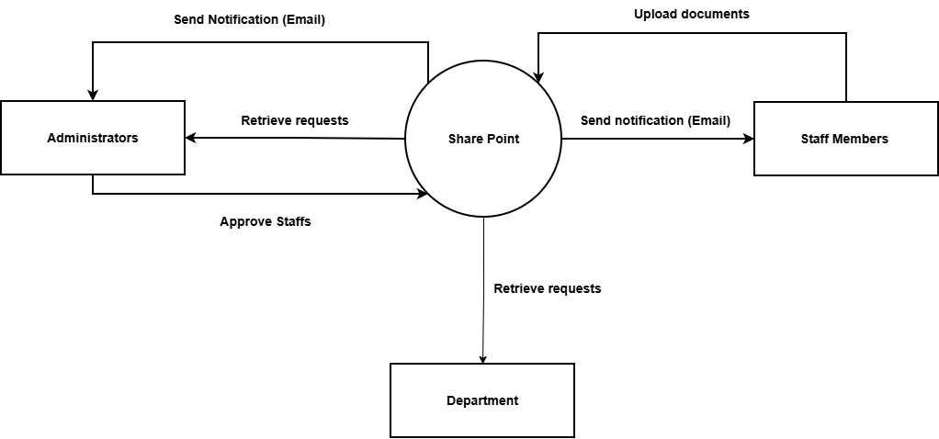
Figure 2.1: SharePoint Context diagram

The context model illustrates how SharePoint interacts with external entities within an organization. The primary external entities include administrators, staff members, departments, management personnel, and email servers. These entities exchange information with the SharePoint system through document uploads, retrieval requests, notifications, approvals, and user authentication processes.
In the context diagram, SharePoint serves as the central processing system that receives inputs from users and provides outputs such as documents, notifications, reports, and communication updates. The context model demonstrates the system's role as a centralized information management platform.

2.2.3 Interaction Model (Sequence Diagram)

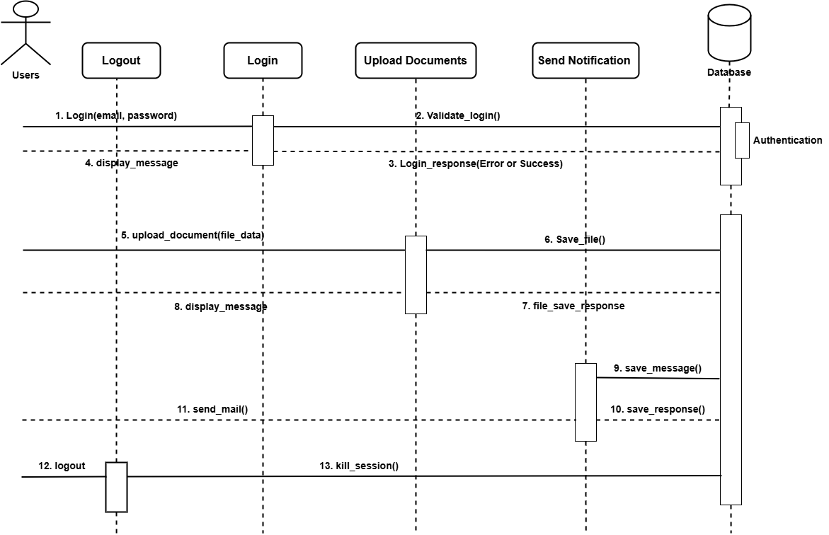
Figure 2.2: SharePoint Sequence diagram

The sequence diagram describes the interactions that occur when a user uploads and shares a document within SharePoint. The process begins when a user logs into the system using valid credentials. The system authenticates the user and grants access to the appropriate resources.
The user then uploads a document to the document repository. SharePoint validates the document and stores it in the database. Once the upload process is complete, the system sends notifications to designated recipients. Recipients receive alerts and access the document through the platform. The system records all interactions and updates the audit log accordingly.
The sequence diagram demonstrates the flow of communication among users, the system interface, the document repository, and notification services.

2.2.4 Behavioral Model (Use Case Diagram)

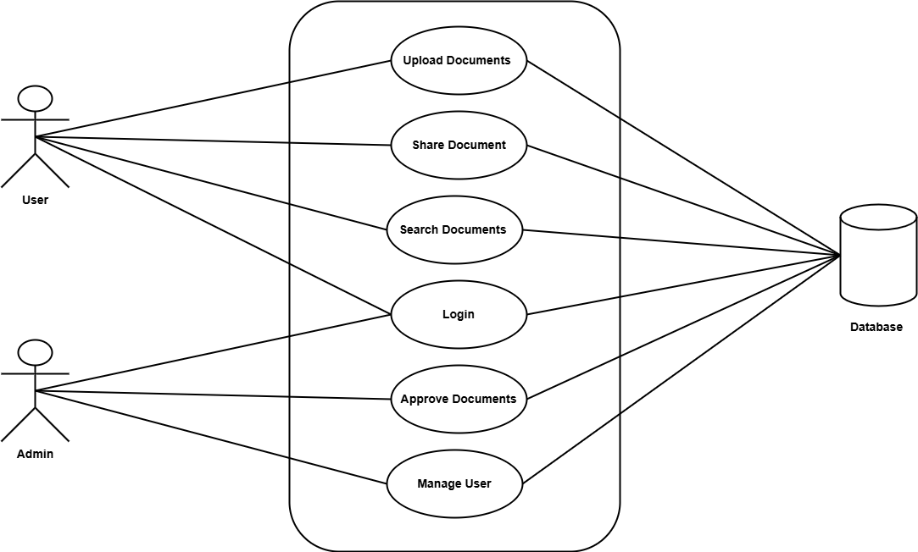
Figure 2.3: SharePoint diagram

The use case diagram illustrates the interactions between users and the SharePoint system. The primary actors include administrators and staff members.
Major use cases include:
- Login
- Upload Document
- Edit Document
- Share Document
- Search Document
- Approve Document
- Generate Reports
- Manage Users
The use case model highlights the functionality available to different categories of users and demonstrates how the system supports organizational communication and document management.

2.2.5 Features of Microsoft SharePoint
Microsoft SharePoint offers several features that contribute to effective document management and organizational communication. The system provides centralized document storage, enabling users to access documents from a single repository. This feature improves information accessibility and reduces duplication of records.
Another important feature is workflow automation. Automated workflows reduce manual processing requirements and improve administrative efficiency. SharePoint also supports document version control, allowing organizations to maintain document histories and track modifications.
The system provides advanced search functionality that enables users to retrieve information quickly. In addition, SharePoint supports role-based access control, ensuring that only authorized users can access sensitive documents.
Email integration is another significant feature. Users receive notifications regarding document updates, approvals, and organizational announcements. The platform also supports collaboration through discussion boards, team sites, and shared workspaces.

2.2.6 Development Tools and Development Environment
Microsoft SharePoint is primarily developed using Microsoft's technology stack. The system utilizes ASP.NET and C# programming languages for application development. The backend database is typically Microsoft SQL Server, which stores documents, user information, and system records.
SharePoint can be deployed on Windows Server environments and integrated with Microsoft Azure cloud services. The development environment includes Visual Studio, SharePoint Designer, and various Microsoft development frameworks.
The platform supports both on-premises and cloud-based deployments, providing organizations with flexibility in system implementation.

2.2.7 Review of the Good Features
One of the most notable strengths of SharePoint is its centralized document management capability. By storing documents within a unified repository, the system improves information accessibility and reduces the risk of document duplication.
The workflow automation functionality significantly enhances organizational efficiency. Automated approval processes reduce delays and improve accountability. Organizations can customize workflows to align with their operational requirements.
SharePoint's security features are also highly effective. Role-based access control and authentication mechanisms help protect sensitive information and maintain data confidentiality.
Another advantage is the platform's collaboration capability. Multiple users can work on documents simultaneously, facilitating teamwork and improving productivity.
The availability of comprehensive audit logs and tracking mechanisms further strengthens accountability. Administrators can monitor user activities and verify document access histories.

2.2.8 Review of the Bad Features
Despite its advantages, SharePoint has several limitations. One major challenge is the high cost associated with licensing and implementation. Smaller institutions may find the financial requirements difficult to justify.
The system can also be complex to configure and manage. Effective deployment often requires specialized technical expertise and ongoing administrative support.
Another limitation is that SharePoint provides many enterprise-level features that may not be necessary for organizations seeking a simple memo management solution. This complexity can result in reduced usability for some users.
The infrastructure requirements of SharePoint can also be substantial. Organizations may need significant hardware resources and network capacity to support optimal performance.

2.2.9 Summary of the System Review
Microsoft SharePoint is a powerful enterprise document management and collaboration platform that provides extensive support for document storage, workflow automation, communication, and organizational collaboration. Its advanced features make it suitable for large institutions seeking comprehensive information management solutions.
However, the system's complexity, infrastructure requirements, and licensing costs may limit its suitability for institutions seeking a specialized memo management solution. The proposed Memo Management System will adopt useful SharePoint concepts such as document tracking, notifications, and centralized storage while maintaining simplicity, affordability, and ease of use.

2.3 Review of System Two: OpenKM Document Management System

2.3.1 Description of the System
OpenKM is an open-source Document Management System (DMS) designed to facilitate the creation, storage, organization, retrieval, and management of electronic documents within organizations. The system was developed to help organizations transition from paper-based document management practices to digital environments that improve efficiency, security, and accessibility. OpenKM is widely used in educational institutions, healthcare organizations, government agencies, and private enterprises due to its flexibility, scalability, and cost-effectiveness.
The primary objective of OpenKM is to provide a centralized platform where documents can be securely stored and managed throughout their lifecycle. The system enables users to upload documents electronically, classify them into folders, assign metadata, and retrieve them whenever needed. By maintaining documents in a digital repository, organizations can reduce paper usage, improve record management practices, and facilitate easier access to information.
One of the major advantages of OpenKM is its ability to support document indexing and search functionality. Traditional paper-based filing systems often require significant time and effort to locate specific documents. OpenKM addresses this challenge by indexing documents and enabling users to perform keyword-based searches. This capability significantly improves document retrieval efficiency and organizational productivity [13].
The system also supports workflow management, allowing organizations to automate document approval and review processes. Workflow automation ensures that documents follow predefined routes and approval hierarchies, thereby reducing delays and enhancing accountability. Automated workflows minimize manual intervention and support effective business process management [6].
Another important feature of OpenKM is version control. Organizations often update documents periodically, making it important to maintain records of previous versions. OpenKM automatically stores document versions and enables users to access historical records whenever necessary. This functionality supports auditing, compliance, and information integrity.
OpenKM incorporates robust security mechanisms to protect organizational information. User authentication, role-based access control, and permission management ensure that only authorized individuals can access specific documents. These security measures help organizations safeguard confidential information and comply with institutional policies regarding information management [14].
In addition to document storage and retrieval, OpenKM supports collaboration among users. Employees can share documents, exchange comments, and participate in workflow activities within the system. This collaborative environment enhances communication and improves coordination among departments.
The system is web-based and can be accessed through standard web browsers. This architecture eliminates the need for extensive software installations and allows users to access documents from different locations. Web-based accessibility is particularly beneficial for organizations with multiple departments or distributed operations [7].
OpenKM also supports document categorization through folders, tags, and metadata. Proper classification improves document organization and simplifies information retrieval. Metadata management allows organizations to define attributes such as document type, author, department, and creation date.
Furthermore, OpenKM supports electronic archiving. Archived documents remain securely stored within the system and can be retrieved whenever required. This functionality contributes to effective records management and preservation of institutional knowledge.
Due to its open-source nature, OpenKM offers flexibility for customization and integration. Organizations can modify system functionalities to suit their specific operational requirements. This adaptability has contributed significantly to the system's popularity among institutions seeking cost-effective document management solutions.
Overall, OpenKM represents a comprehensive document management solution that addresses many challenges associated with traditional paper-based information management systems. Its capabilities in document storage, workflow automation, version control, security, and retrieval make it relevant to the development of the proposed Memo Management System.

2.3.2 Context Model of OpenKM
The context model illustrates the interaction between OpenKM and external entities. The main external entities include users, administrators, departments, management personnel, and email servers.
Users interact with the system by uploading, retrieving, editing, and searching for documents. Administrators manage user accounts, permissions, and system configurations. Departments exchange information through the system by storing and accessing documents relevant to their operations. Email servers facilitate notification services by sending alerts related to workflow activities and document updates.
At the center of the context model is the OpenKM Document Management System, which processes requests from users and returns outputs such as stored documents, search results, notifications, and workflow updates. The context model demonstrates how OpenKM serves as a centralized repository for organizational information.
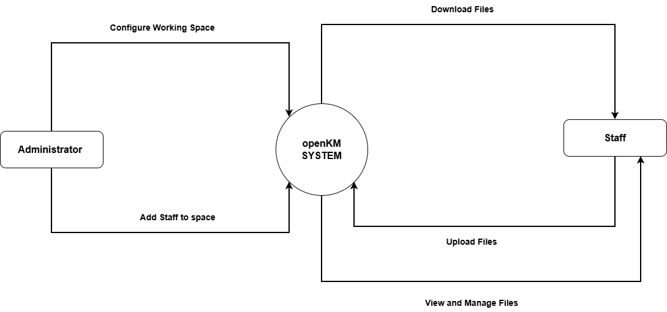
Figure 2.4: OnpenKM context diagram

The context model highlights the role of OpenKM as the core information processing system within an organization. External entities provide inputs in the form of documents, requests, and administrative actions. The system processes these inputs and generates outputs including document retrieval services, workflow notifications, and management reports.
The model illustrates how information flows between users and the system while emphasizing the centralized nature of document management. Such centralization reduces duplication of records and improves consistency in information handling practices.

2.3.3 Interaction Model (Sequence Diagram)
The interaction model describes the sequence of activities that occur when a user uploads and retrieves a document within OpenKM.
The process begins when the user logs into the system. OpenKM authenticates the user by validating login credentials. Upon successful authentication, the user gains access to the system dashboard.
The user then uploads a document and enters the required metadata information. OpenKM validates the document and stores it within the document repository. The indexing engine processes the document and updates the search database.
When another user needs the document, a search request is submitted through the system interface. The search engine retrieves matching records and displays them to the user. The selected document is then accessed from the repository and delivered to the requesting user.
Throughout this process, system activities are recorded within audit logs for monitoring and accountability purposes.
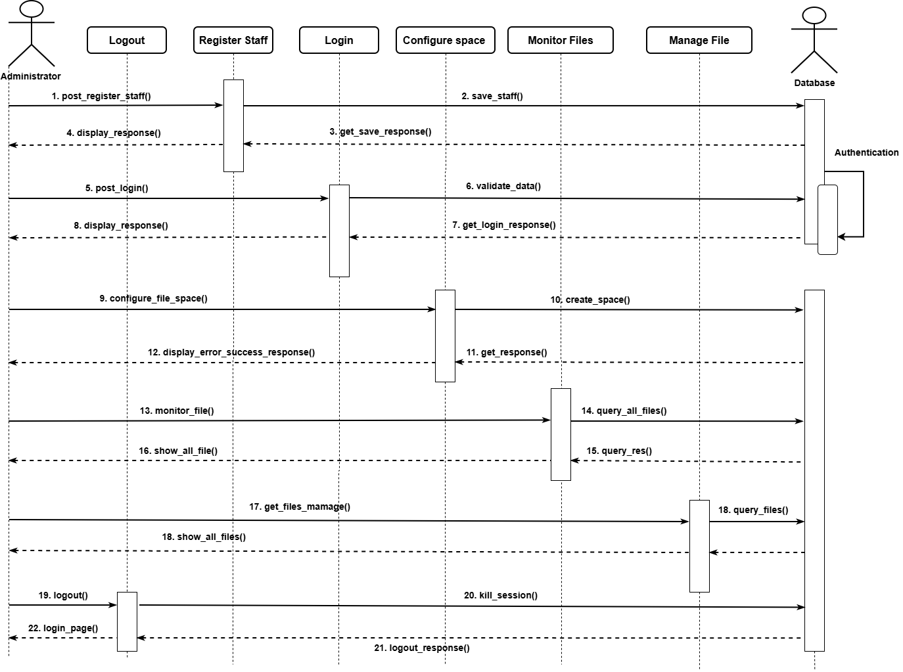
Figure 2.5: OpenKM sequence diagram

The sequence diagram demonstrates the interaction among users, the application interface, the document repository, the indexing engine, and the database. It highlights the chronological flow of events involved in document storage and retrieval.
The model emphasizes the importance of authentication, indexing, and audit logging in ensuring secure and efficient document management. It also illustrates how OpenKM facilitates quick access to information while maintaining accurate records of user activities.

2.3.4 Behavioral Model (Use Case Diagram)
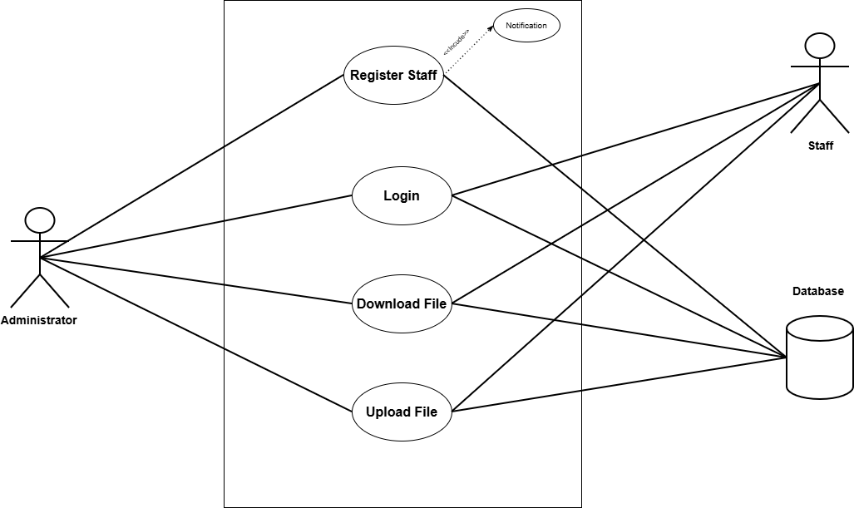
Figure 2.6: OpenKM User Case diagram

The use case diagram illustrates the interactions between the administrator and staff within the OpenKM system. The administrator can register staff members into the system, and this registration process includes sending a notification to the staff. The administrator can also log in, upload documents, and download documents from the system.
The staff receives notifications upon registration and can log in to access the system. Once authenticated, staff members can upload and download documents within their assigned space.
All major operations, including registration, login, file upload, and file download, communicate with the system database, where user information and document data are securely stored and managed. This ensures proper authentication, data integrity, and efficient document handling within the OpenKM system.

2.3.5 Features of OpenKM
OpenKM offers numerous features that enhance organizational document management practices.
One notable feature is electronic document storage, which enables organizations to maintain digital repositories rather than physical filing cabinets. This reduces paper consumption and improves accessibility.
The advanced search engine allows users to locate documents using keywords, metadata, and content-based searches. Efficient retrieval improves productivity and minimizes time spent searching for information.
Workflow automation supports document routing, approvals, and reviews. Automated workflows improve accountability and reduce delays in administrative processes.
Version control ensures that document modifications are recorded and previous versions remain accessible. This feature supports auditing and information integrity.
The system also provides robust security through authentication, authorization, and role-based access control mechanisms. These features protect sensitive organizational information from unauthorized access.
Additionally, OpenKM supports document archiving, metadata management, collaboration tools, audit trails, and email notifications, making it a comprehensive document management solution.

2.3.6 Development Tools and Development Environment
OpenKM is primarily developed using Java technologies. The platform utilizes the Java programming language and the Spring Framework to support enterprise-level application development.
The system typically operates on Apache Tomcat application servers and uses relational database management systems such as MySQL, PostgreSQL, Oracle Database, or Microsoft SQL Server for data storage.
The development environment supports deployment on both Linux and Windows operating systems. OpenKM's web-based architecture enables users to access the system through standard web browsers without requiring specialized client software.
The use of open-source technologies contributes to lower implementation costs and allows organizations to customize the system according to their specific requirements.

2.3.7 Review of the Good Features
One of the strongest advantages of OpenKM is its cost-effectiveness. As an open-source solution, organizations can implement the system without incurring substantial licensing expenses. This makes it particularly attractive to educational institutions and public-sector organizations operating under budget constraints.
Another major strength is the system's advanced search functionality. Efficient document retrieval improves productivity and reduces the time required to locate important records.
The workflow automation feature enhances operational efficiency by streamlining document approval and review processes. Automated workflows minimize manual interventions and improve accountability.
OpenKM also provides strong document security through user authentication, access control, and permission management mechanisms. These features help organizations protect sensitive information.
The system's support for version control and electronic archiving contributes significantly to effective records management. Organizations can maintain historical document records while ensuring data integrity.
Finally, the flexibility and customization capabilities of OpenKM enable organizations to adapt the system to their unique operational requirements.

2.3.8 Review of the Bad Features
Despite its strengths, OpenKM has several limitations.
One challenge is the complexity of implementation and customization. Organizations often require technical expertise to configure workflows, security settings, and advanced functionalities.
The user interface may appear complicated for inexperienced users. New users may require training before becoming fully comfortable with the system.
Although OpenKM supports email notifications, it does not provide extensive built-in SMS notification capabilities. Additional integrations may be required to support mobile messaging services.
Another limitation is that OpenKM focuses primarily on general document management rather than memo-specific communication processes. Features such as read receipts and targeted memo distribution may require additional customization.
Performance issues may also arise when managing very large document repositories without adequate server resources.

2.3.9 Summary of the System Review
OpenKM is a comprehensive open-source document management system that provides powerful capabilities for document storage, retrieval, workflow automation, security, and collaboration. Its flexibility, scalability, and affordability have made it a popular choice among educational institutions and organizations seeking digital document management solutions.
The system demonstrates several features that are relevant to the proposed Memo Management System, including document archiving, workflow management, search functionality, and access control. These capabilities contribute significantly to efficient information management and organizational communication.
However, OpenKM was not specifically designed for memo management and lacks certain communication-focused functionalities such as advanced read-receipt tracking, targeted memo distribution, and integrated SMS notifications. The proposed Memo Management System seeks to incorporate the strengths of OpenKM while introducing specialized memo management features that better address the communication needs of Koforidua Technical University.

2.4 Review of System Three: Upload care

2.4.1. Description of the System
Upload care is a cloud-based file uploading and management service designed for web and mobile applications. It allows users and developers to upload, store, process, and deliver files such as images, PDFs, and videos. The system provides fast content delivery via a CDN and supports file transformations, security, and storage management. Unlike general cloud storage platforms, Upload care is API-driven and intended for integration into custom applications.

2.4.2. Context Diagram for Upload care

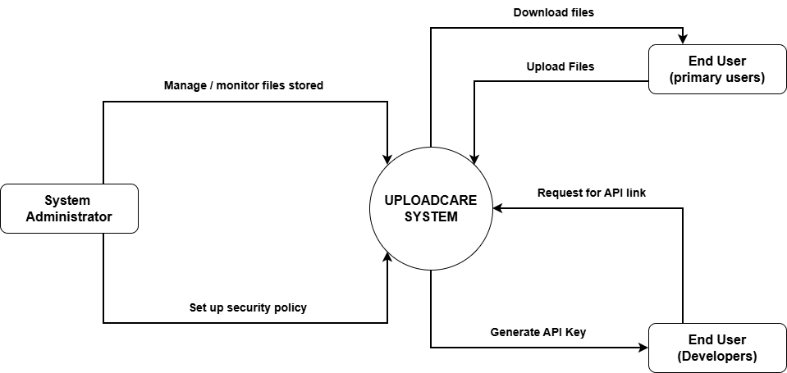
Figure 2.7: Upload care context diagram

The context diagram illustrates the interactions between Upload care and its external users. End users can upload files to the system and download files when needed. Developers interact with the system by requesting API links, and the system generates API keys to allow secure integration with applications. System administrators manage and monitor file storage, as well as configure security settings to ensure safe and reliable file handling. The system communicates with all users through the internet and provides fast file delivery via its cloud infrastructure.

2.4.3 Use Case Diagram for Upload care

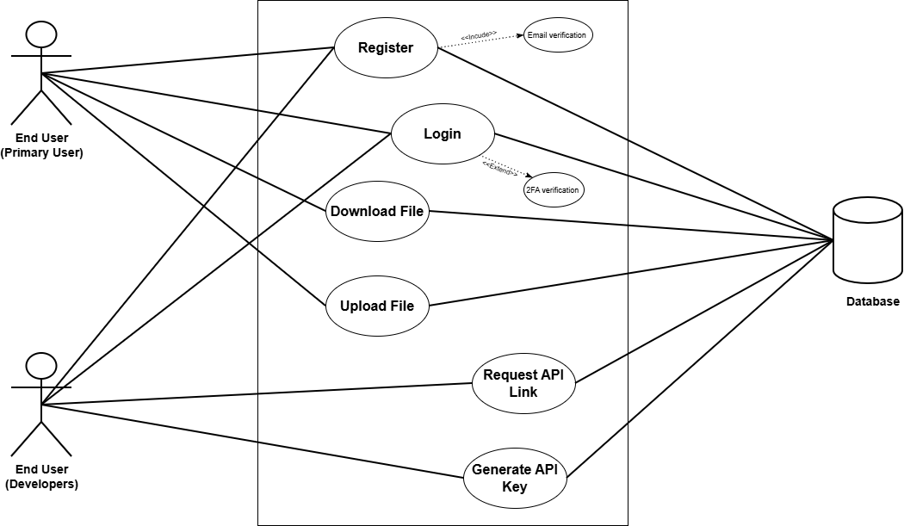
Figure 2.8: Upload care use case diagram

The use case diagram for Upload care shows how different users interact with the system. End users can register, log in, upload files, and download files, with registration including login verification and login supporting two-factor authentication for security. Developers can register, log in, request API links, and generate API keys to integrate Upload care into their applications. All these actions registration, login, file upload/download, API requests, and key generation are connected to the system database, which stores user credentials, file information, and API data. This ensures secure, organized, and manageable interactions between the users and the Upload care cloud service.

2.4.4. Sequence Diagram for Upload care

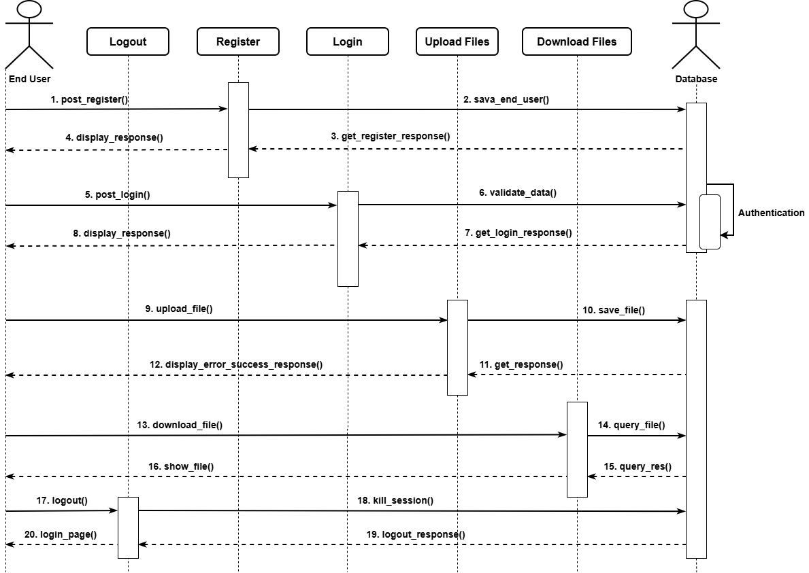
Figure 2.9: Upload care sequence diagram

The sequence diagram illustrates the step-by-step interaction between a user and the Upload care system. First, the user registers, and the system saves the registration information in the database before returning a response to the user confirming success or failure. Next, the user logs in; the system validates the login data, authenticates the information against the database, and sends back a response indicating whether the login was successful. When the user uploads a file, the system stores the file in the database and returns a confirmation or error message. For file requests, the system queries the database and returns the retrieved files to the user. Finally, when the user logs out, the system terminates all active sessions and sends a logout confirmation response to the user. This sequence ensures secure, organized, and trackable user interactions with the Upload care system.

2.4.5. Features of the System
Upload care provides users with the ability to upload and store files, including images, videos, PDFs, and other large files. It supports automatic processing and optimization of images and videos to improve performance and reduce load times. The system ensures fast content delivery through its content delivery network (CDN) and provides secure access and authentication. Users can also upload files using a drag-and-drop interface or select files from multiple sources, while a developer-friendly API allows easy integration with web and mobile applications.

2.4.6. Development Tools and Development Environment of the System
Upload care is built to support developers through APIs and SDKs for JavaScript, PHP, Python, and Ruby. It also provides a web integration widget for seamless implementation into applications. The system operates on cloud infrastructure with CDN support, ensuring scalability and high availability. It is compatible with most web frameworks and mobile platforms, making it flexible for integration into a variety of applications and development environments.

2.4.7. Review of the Good Features
Upload care offers easy and fast file uploading through a drag-and-drop interface, making it user-friendly for both end users and developers. The system provides scalable storage for large files and supports file transformations such as resizing, compressing, and cropping. Files are delivered quickly through an automatic content delivery network (CDN), ensuring fast access, while secure and reliable cloud storage protects user data. Additionally, the developer-friendly API allows seamless integration into custom web and mobile applications.

2.4.8. Review of the Bad Features
Despite its strengths, Upload care is not specifically designed for academic use, such as managing examination scripts. The system does not include workflow automation or notifications for lecturers, which limits its use in academic environments. It requires an internet connection to operate, and there is limited control over the internal database or indexing without custom implementation. Furthermore, higher storage limits and advanced features require a paid subscription, which may increase operational costs.

2.4.9. Summary of the System Review
Overall, Upload care provides a robust, scalable, and developer-friendly platform for file uploading, processing, and delivery. It simplifies cloud file management and ensures fast content access through its CDN. However, it is not tailored for academic environments and lacks specialized features such as structured indexing, time-based access control, and workflow management. While Upload care can efficiently handle the file storage component of an examination script system, additional development is necessary to meet academic-specific requirements.

References (IEEE Referencing Style)
[1] M. Ramoni, “Development of E-Memo System for Organisational Internal Communication,” RepCom SEET, 2019.
[2] A. Afolabi and A. Abioye, “Document Management Practices in Academic Institutions,” International Journal of Information Management, vol. 45, pp. 102–110, 2020.
[3] W. Olatokun and A. Adebayo, “Electronic Document Management Systems and Organizational Efficiency,” African Journal of Library, Archives and Information Science, vol. 22, no. 1, pp. 1–10, 2012.
[4] T. Dahlberg, J. Guo, and J. Ondrus, “A Critical Review of Mobile Payment Research,” Electronic Commerce Research and Applications, vol. 14, no. 5, pp. 265–284, 2015.
[5] S. Akanbi and A. Olalekan, “Paperless Office Systems and Environmental Sustainability,” Journal of Information Systems and Technology, vol. 11, no. 2, pp. 45–53, 2021.
[6] A. Dennis, B. Wixom, and R. Roth, Systems Analysis and Design, 6th ed. Hoboken, NJ, USA: Wiley, 2015.
[7] I. Sommerville, Software Engineering, 10th ed. Boston, MA, USA: Pearson, 2016.
[8] R. S. Pressman and B. R. Maxim, Software Engineering: A Practitioner’s Approach, 8th ed. New York, NY, USA: McGraw-Hill, 2015.
[9] K. C. Laudon and J. P. Laudon, Management Information Systems: Managing the Digital Firm, 15th ed. Harlow, U.K.: Pearson, 2018.
[10] A. Dennis, D. Tegarden, and B. Wixom, Systems Analysis and Design with UML, 5th ed. Hoboken, NJ, USA: Wiley, 2012.
[11] J. Valacich and J. George, Modern Systems Analysis and Design, 8th ed. Boston, MA, USA: Pearson, 2017.
[12] E. Turban, L. Volonino, and G. Wood, Information Technology for Management, 11th ed. Hoboken, NJ, USA: Wiley, 2018.
[13] P. Rob and C. Coronel, Database Systems: Design, Implementation, and Management, 13th ed. Boston, NJ, USA: Cengage Learning, 2019.
[14] T. Connolly and C. Begg, Database Systems: A Practical Approach to Design, Implementation and Management, 6th ed. Harlow, U.K.: Pearson, 2015.
[15] R. Elmasri and S. Navathe, Fundamentals of Database Systems, 7th ed. Boston, MA, USA: Pearson, 2017.
[16] J. W. Satzinger, R. B. Jackson, and S. D. Burd, Systems Analysis and Design in a Changing World, 7th ed. Boston, MA, USA: Cengage Learning, 2016.
[17] M. Armstrong, Armstrong’s Handbook of Management and Leadership, 5th ed. London, U.K.: Kogan Page, 2018.
[18] B. Boiko, Content Management Bible, 2nd ed. Indianapolis, IN, USA: Wiley Publishing, 2014.
[19] J. R. Schwalbe, Information Technology Project Management, 9th ed. Boston, MA, USA: Cengage Learning, 2019.
[20] D. M. Kroenke and D. J. Auer, Database Processing: Fundamentals, Design, and Implementation, 15th ed. New York, NY, USA: Pearson, 2018.
[21] OpenKM, “OpenKM Document Management System Documentation,” 2023.

